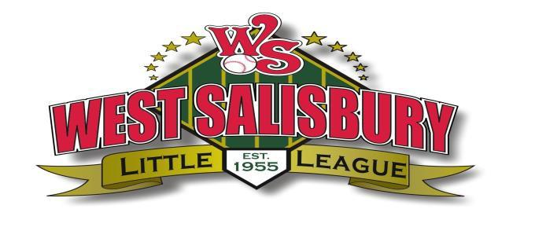
Dear Potential Sponsor,
Thank you for your continued commitment to our community and support of West Salisbury Little League. Because of your support, we continue to have successful baseball seasons each year. As you are aware, operating a successful Little League program requires numerous volunteers, community partners and financial support. Each baseball season we have countless volunteers devoting their time and energy to make our league run as smoothly as possible. In addition to our volunteers, the league requires community financial support. Player registration fees are kept as low as possible and cover only a portion of the league expenses. The remaining costs are covered by donations from our wonderful sponsors and donors of our community. Your generous sponsorship dollars provide an opportunity for children to learn the game of baseball, understand the value of teamwork, and establish childhood memories that will last a lifetime. All sponsorship/donations help West Salisbury Little League:
- Maintain affordable registration fees for all players
- Purchase quality equipment for the optimal safety and experience of our players
- Support the operational cost of our league such as insurance, website expenses, etc.…
- Continue to be completely managed by volunteers, including coaches, umpires, scorekeepers, board members and other countless volunteers
We need your help to ensure another successful West Salisbury Little League Season. All donations are tax deductible as West Salisbury Little League is a 501(c)(3) organization.
Please review the attached Sponsorship Form for a listing of continued and additional benefits. Please send your sponsorship before February 15, 2026.
Thank you in advance for your continued commitment to our community and support of West Salisbury Little League. Your generosity allows are league to provide excellent experience to our players and community each year.
For more information, please contact us directly at kristenwheatley@gmail.com or visit our web site at www.westsalisburylittleleague.com.

West Salisbury Little League Sponsorship Form

Team Sponsorship Fee: $800 per team
Includes business name on uniforms

Banner Sponsorship Fee: $500 (1st year banner Sponsor)
Includes banner and visible placement
$400 (existing banner Sponsor)
Includes visible placement of existing banner
Team & Banner
Sponsorship Fee: $1000
Includes both listed above

Company Name:_____________________________________________________
Company Contact Name:____________________________________________
Title:__________________________________________________________________
Address:______________________________________________________________
City/State/Zip:_______________________________________________________
Telepone#:___________________________________________________________
Email:_________________________________________________________________
Signature:_____________________________________________________________

Payment Due Date: February 15, 2026
Make all checks payable to West Salisbury Little League
Mail to: WSLL PO BOX 2102 Salisbury, MD 21802
Please email electronic Logo to Kristenwheatley@gmail.com

Contact Information:
Kristen Wheatley, President
WSLL Board of Directors
(443)359-1389

